The Title Should Be in Title Case (See Below), Single Spaced, Times New Roman, Bold 14-point, Left-justified, with a Maximum of 200 Characters

First Author¹, Second Author^{2*} and Third Author^{1,3} (Times New Roman 12-pt left-justified) Each name should have a superscript Arabic number to reference the author’s affiliation. A superscript asterisk after the affiliation number indicates the presenting author.

¹ Affiliation of the first author, Department/Institution, State/Province, Country. (12pt)
² Affiliation of the second author, Department/Institution, State/Province, Country. (12pt)
³ Affiliation of the third author, Department/Institution, State/Province, Country. (12pt)
* Presenting author

Key Techniques: Indicate the 2-3 key techniques that are used in this work.

Keywords: Choose 3-5 keywords that describe the work. Avoid repeating key techniques here.

Your submission must be a Microsoft Word file in .doc or .docx formats. For the body of the text, use a 12-point Times New Roman font and single spacing between lines. Avoid individualized formatting and special typefaces. The body of the text (i.e., excluding title, authors, affiliations, key techniques, keywords and references) should be full-justified and less than 350 words. Include one blank line between paragraphs.

One figure and figure caption can be included in your submission if desired (Figure 1). Remember to include scale markers if appropriate. The figure should be placed after the body of the abstract text (before any references) and captions should be placed below the figure. Colour figures are encouraged; consider accessibility when designing your figure, so that your images can be easily understood by colour-blind and visually impaired readers.

References can be included at the end of the text, using an appropriate reference style (e.g., Nature Citation Style). References should be indicated within the text using [1] or [1-2] style markers. All submissions will be reviewed by the Scientific Organising Committee based on (a) relevance to the conference topics areas (b) scientific content, quality, and innovation, (c) clarity of the text, and (d) compliance with this format.

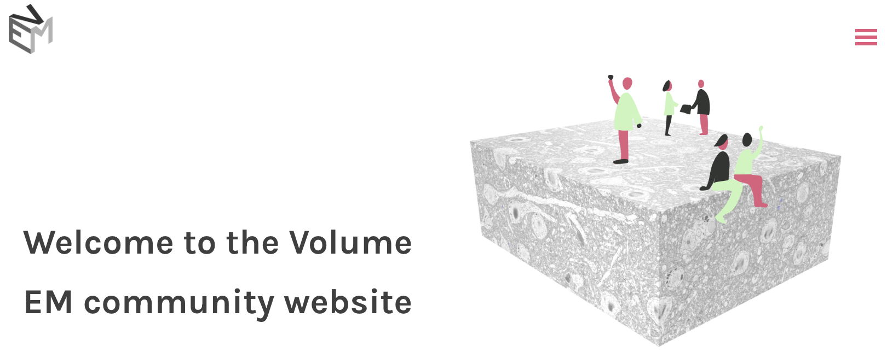
Figure 1. Times New Roman, 12pt., left-justified. Provide a short description of the figure, including labels and scale markers as appropriate.

References: (Times New Roman, 12-pt, left-justified)
1. Author, F. et al. Title of the article. Journal 552, 426–429 (year).
2. Author, F. & Author, S. Article Title: Redux. Journal 333, 708–709 (year).

