
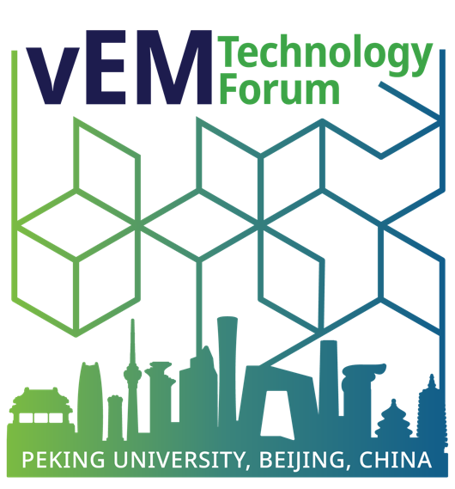

School of Life Sciences
No.5 Yiheyuan Road Haidian District
Beijing, 100871, P.R. China

To: The Visa Officer
Embassy/Consulate of the People’s Republic of China
[City, Country]
Subject: Invitation Letter for Visa Application – 2026 vEM Tech Forum, Beijing, China
Dear Sir or Madam,
On behalf of 2026 vEM Technology Forum, I am pleased to formally invite [Full Name of Attendee] to attend the 2026 vEM Tech Forum to be held at Peking University in Beijing, China, from October 11 to October 15.
The 2026 vEM Tech Forum is an international professional event, which will bring together the global volume electron microscopy (vEM) community to explore advances in life and material sciences and to showcase the latest innovations in microscope platforms, specimen preparation, correlative imaging, automation, and AI-driven software development.
Details of the Event
- Event Name: 2026 vEM Tech Forum
- Dates: October 11 – 15, 2026
- Location: The Zhongguanyuan Global Village, Peking University, No. 126 Zhongguancun North Street, Beijing, 100871, China
- Local Organizer: Peking University
- Official Website: https://indico.pku.edu.cn/e/2026vem.tec.forum
Details of the Invitee
- Full Name: [Full Name as in Passport]
- Nationality: [Nationality]
- Position/Title: [Job Title]
- Employer/Institution: [Employer Name]
- Full Address of Employer: [Address]
Purpose and Duration of Visit
[Mr./Ms./Dr.] [Surname] is invited to participate in the 2026 vEM Tech Forum as a [participant/speaker/panelist/exhibitor]. During the forum, [he/she] will attend [sessions/workshops/panels/exhibitions] and engage in professional exchanges relevant to [his/her] field.
[He/She] intends to stay in China from approximately [Intended Arrival Date] to [Intended Departure Date], after which [he/she] will return to [Home Country].
During [his/her] stay in Beijing, [Mr./Ms./Dr.] [Surname] will be accommodated at:
- Hotel Name: The Zhongguanyuan Global Village
- Address: No. 126 Zhongguancun North Street, Beijing, 100871, China
- Phone: + 86- 10- 62752236
We kindly request that you provide [Mr./Ms./Dr.] [Surname] with the appropriate visa to enable [him/her] to attend this global event in Beijing, China. We assure you that [he/she] will comply with all laws and regulations of the People’s Republic of China and will depart China upon completion of the visit.
If you require any further information or documentation, please do not hesitate to contact us.
Sincerely,
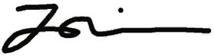
Alice Liang, Ph.D.
Chair, 2026 vEM Tech Forum Organizing Committee
Email: Fengxia.liang@nyulangone.org

